*Shri Shivaji Education Society Amravati’s*

**Science College, Congress Nagar, Nagpur**

*Internal Quality Assurance Cell*

DEPARTMENT OF **COMPUTER SCIENCE**

***INTERNAL ACADEMIC AUDIT***

**2023-2024**

1. A. Faculty Strength:

|  |  |  |  |
| --- | --- | --- | --- |
| Faculty | Recruited | Vacant | Remarks |
| Regular (B.Sc.) | 05+01 | 01 | NIL |
| Regular (BCA) | 02 | 19 | NIL |
| Regular (M.Sc.) | 01 | 04 | NIL |
| Regular (MCA) | 02 | 02 | NIL |
| CHB | 04 | 00 | NIL |
| Adhoc (BCA) | 08 | NIL | NIL |
| Adhoc (M.Sc.) | 03 | NIL | NIL |
| Adhoc (MCA) | 02 | NIL | NIL |
| Non-teaching | 06 | NIL | NIL |

B. Faculty profile

B.Sc. Programmed:

|  |  |  |  |  |
| --- | --- | --- | --- | --- |
| Name | Highest Qualification | Designation | Specialization | Teaching Experience |
| Prof. M. P. Dhore | Ph.D. | Principal and Professor | Pattern Recognition | 27 |
| Prof. S.R. Pande | Ph.D. | Professor | Soft Computing | 34 |
| Prof. R.N. Jugele | Ph.D. | Professor | Multimedia, Programming Language & Cloud Computing | 28 |
| Dr. A.A. Halder | Ph.D., NET | Assistant Professor | Pattern Recognition | 12 |
| Dr. J. K. Keche | Ph.D. | Assistant Professor | Pattern Recognition | 05 |
| Dr. S. R. Gedam | Ph.D. | Assistant Professor | Data Mining | 05 |

BCA Programme

|  |  |  |  |  |
| --- | --- | --- | --- | --- |
| Name | Highest Qualification | Designation | Specialization | Teaching Experience |
| Dr. V. C. Pande | Ph.D. | Assistant Professor | Data Mining | 05 |
| Ms. P. M. Dadhe | Ph.D., NET | Assistant Professor | NLP | 05 |

M.Sc. Programme

|  |  |  |  |  |
| --- | --- | --- | --- | --- |
| Name | Highest Qualification | Designation | Specialization | Teaching Experience |
| Dr. M. T. Wanjari | Ph.D. | Assistant Professor | Pattern Recognition | 05 |

MCA Programme

|  |  |  |  |  |
| --- | --- | --- | --- | --- |
| Name | Highest Qualification | Designation | Specialization | Teaching Experience |
| Mr. A. M. Bodkhe | MCA | Assistant Professor | Computer Application | 05 |
| Ms. Asfiya Sheikh | MCA | Assistant Professor | Computer Application | 05 |

1. Student’s strength

|  |  |
| --- | --- |
| **Year** | **Number of Students Admitted** |
| B.Sc. Semester I | 110 |
| B.Sc. Semester III | 93 |
| B.Sc. Semester V | 114 |
| B.C.A. I | 114 |
| B.C.A. III | 106 |
| B.C.A. V | 107 |
| M.Sc. Semester I | 15 |
| M.Sc. Semester III | 31 |
| M.C.A. I | 32 |
| M.C.A. III | 35 |
| Ph. D | 08 |

|  |  |
| --- | --- |
| P. G. STUDENT INDUCTION PROGRAMME | Yes, No |
| ACADEMIC PLANNINGS | Yes, No |
| BRIDGE COURSE TAUGHT | Yes, No |
| REMEDIAL COURSE TAUGHT | Yes, No |

3. Student Performance

1. Result Analysis (Winter 2023) UG & PG

|  |  |  |  |
| --- | --- | --- | --- |
| Programme Name | Number of students who appeared in the final year examination | Number of students who passed in final year examination | Pass Percentage |
| B.Sc. I | 110 | 76 | 69.09% |
| B.Sc. III | 93 | 77 | 82.79% |
| B.Sc. V | 114 | 96 | 84.21% |
| B.C.A.I | 115 | 70 | 60% |
| B.C.A. III | 106 | 87 | 82.07% |
| B.C.A. V | 107 | 97 | 87.85% |
| M.Sc. I | 32 | 23 | 65.71% |
| M.Sc. III | 31 | 29 | 93.55% |
| M.C.A. I | 32 | 23 | 65.71% |
| M.C.A. III | 34 | 29 | 85.29% |

1. Result Analysis (Summer 2024) UG & PG

|  |  |  |  |
| --- | --- | --- | --- |
| Programme Name | Number of students who appeared in the final year examination | Number of students who passed in final year examination | Pass Percentage |
| B.Sc.II | 105 | 52 | 49.52% |
| B.Sc. IV | 91 | 62 | 68.13% |
| B.Sc. VI | 118 | 86 | 72.88 |
| B.C.A.II | 110 | 49 | 44.54% |
| B.C.A. IV | 104 | 73 | 70.19% |
| B.C.A. VI | 105 | 95 | 90% |
| M.Sc. II | 15 | 12 | 80% |
| M.Sc. IV | 31 | 27 | 87.09% |
| M.C.A. II | 30 | 26 | 86.47% |
| M.C.A. IV | 30 | 30 | 100% |

1. Achievements
2. (Medals/Awards/Prizes at University level)

|  |  |  |  |
| --- | --- | --- | --- |
| Sr. No. | Name of the Students | Class | Title |
| 1 | Achal Kale | M.Sc.-I Year | Best Presenter in International Conference (ICIESM-2k24) |
| 2 | Sparch Gajbiye | M.Sc.-I Year | Best Presenter in International Conference (ICIESM-2k24) |

Merit Position of UG Students in RTMNU (B.Sc. (Computer Science))

|  |  |  |
| --- | --- | --- |
| Sr. No. | Name of the Students | Merit Position |
| 1 | Vishaka. M. Khiani | 4th |

Merit Position of UG Students in RTMNU (BCA)

|  |  |  |
| --- | --- | --- |
| Sr. No. | Name of the Students | Merit Position |
| 1 | Srushti. D. Motharkar | 4th |

Merit Position of PG Students in RTMNU (M.Sc.)

|  |  |  |
| --- | --- | --- |
| Sr. No. | Name of the Students | Merit Position |
| 1 | Ku. Simran R. Kadbe | 2nd |
| 2 | Ku. Leena S. Dupade | 4th |

Merit Position of PG Students in RTMNU (M.C.A.)

|  |  |  |
| --- | --- | --- |
| Sr. No. | Name of the Students | Merit Position |
| 1 | Mitali . A. Bonde | 3rd |

4. Student’s Progression:

|  |  |  |
| --- | --- | --- |
| No. of students enrolling in higher Education | Name of institution joined | Name of program admitted to |
| UG to PG | - | - |
| PG to Research | - | - |
| Placement | - | - |
| On-Campus | - | - |
| Off-Campus | 20 | 04 |

* 1. Students’ publication in Conferences/ Journals:

|  |  |  |  |
| --- | --- | --- | --- |
| Title of the Paper | Name of Author | Title of Conferences/ Journals | Year of publication |
| Fake News Detection using Machine Learning | Achal Kale | International Conference on Innovation in Engineering, Science and Management (ICIESM-2k24)  ISSN:2394-8051 | 2023 |
| Fake News Detection using Machine Learning | Sparch Gajbiye | International Conference on Innovation in Engineering, Science and Management (ICIESM-2k24)  ISSN:2394-8051 | 2023 |

* 1. Students’ participation in Seminar/ Conferences:

|  |  |  |  |
| --- | --- | --- | --- |
| Sr. No. | Name of Students | Conference type | Participation as |
|  | Sparch Gajbiye | International | Paper Presenter |
|  | Achal Kale | International | Paper Presenter |

* 1. Students’ Extension Activity/ Extracurricular activity

|  |  |  |
| --- | --- | --- |
| Sr. No. | Name of the activity | The number of students who Participated |
| 1 | Hackathon Competition organized by MECL, Nagpur | 09 |
|  | Drama Competition Organized by YCCE, Nagpur | 01 |

* 1. Participation of Students in online/MOOCs courses/ NPTEL/ SWAYAM

|  |  |  |
| --- | --- | --- |
| Sr. No. | Name of the Students | MOOCs / NPTEL/ SWAYAM |
| 1 | Swati Jamgade | SWAYAM |
| 2 | Bhagyashree Mahulkar | SWAYAM |
| 3 | Sana Firdous | SWAYAM |
| 4 | Bhavika A. Raut | SWAYAM |
| 5 | Sakshi B. Pawar | SWAYAM |
| 6 | Vidhi Soneji | SWAYAM |
| 7 | Simran Kadbe | SWAYAM |
| 8 | Ashish S. Waikar | SWAYAM |

5. Faculty

1. Research Paper Publications
2. Total Number of publications:
3. International:
4. National:
5. Bibliometrics of the publications during the last Academic year based on average citation index in Scopus/ Web of Science or PubMed/ Indian Citation Index

|  |  |  |  |  |  |  |  |
| --- | --- | --- | --- | --- | --- | --- | --- |
| Sr. No. | Name of Author | Title of the Paper | Title of journal | Year of publication | Citation Index | Institutional affiliation as mentioned in the publication | Number of citations excluding self-citation |
| 1 | Prof. R. N. Jugele | Enhancing Network Security: Pinpointing Similarities  and Differences of Machine Learning Models for Firewall  Intrusion Detection | Indian Journal of Technical Education, Indexed in the UGC-Care Journal list, Volume 47 l Special Issue l No. 2 | 2024 |  |  |  |
| 2 | Prof. R. N. Jugele | Enhancing Network Security: Pinpointing Similarities and differences of deep  Learning Models for Firewall Intrusion Detection. | Journal of Engineering and Technology  Management  ELSEVIER (scopus indexed)  ISSN: 1879-1719 | 2024 |  |  |  |
| 3 | Prof. R. N. Jugele | Analyze the Avalanche effect and its strength in Cryptographic Algorithms | Journal of Engineering and Technology Management 72 (2024) | 2024 |  |  |  |
|  | Dr. A.A. Halder | Integration of Deep Learning with Digital Image Processing for Enhanced  Feature Extraction | RES MILITARIS  (Social Science Journal)  ISSN: 2265-6294(Spring 2023) | 2023 | - | - | - |
|  | Varsha C. Pande | Quantum Blockchain: Unraveling the Potential of  Quantum Cryptography for Distributed Ledgers | International Journal on Recent and Innovation Trends in Computing and Communication (SCOPUS)  ISSN: 2321-8169 Volume: 11 Issue: 11s | 2023 |  |  |  |
|  | Dr. Manish T. Wanjari | Perspective on Big Data Hadoop Tools and Technologies | Ajasra (Peer Reviewed Refereed UGC CARE Group 1 International Journal) ISSN: 2278-3741 Vol. 13, Issue No. 2 | 2024 |  |  |  |
|  | Dr. Shilpa Gedam | Implementation of Ensemble Learning to Predict Learner’s Attainment—A Random Forest Classifier | Part of the book series: Lecture Notes in Networks and Systems, Springer Nature Link ((LNNS, volume890)) | 2024 |  |  |  |
|  | Dr. Shilpa Gedam | A Study of ARIMA Model to Safeguard the Quality of Soil in the Drip Irrigation System | Part of the book series: Algorithms for Intelligent Systems ((AIS)), Springer Nature Link | 2023 |  |  |  |
|  | Ms. Asfiya Shaikh | Enhancing Network Security: Pinpointing Similarities  and Differences of Machine Learning Models for Firewall  Intrusion Detection | Indian Journal of Technical Education, Indexed in the UGC-Care Journal list, Volume 47 l Special Issue l No. 2 | 2024 |  |  |  |
|  | Ms. Asfiya Shaikh | Enhancing Network Security: Pinpointing Similarities and differences of deep  Learning Models for Firewall Intrusion Detection. | Journal of Engineering and Technology  Management  ELSEVIER (scopus indexed)  ISSN: 1879-1719 | 2024 |  |  |  |
|  | Ms. Amruta Thakur | Analyze the Avalanche effect and its strength in Cryptographic Algorithms | Journal of Engineering and Technology Management 72 (2024) | 2024 |  |  |  |
|  | Dr. A.A. Halder | Advancement in Iris Recognition Techniques for Biometric Authentication System | Journal of Namibian Studies ,39 S1(2023) 960-969 ISSN:2197-5523 | 2023 |  |  |  |
|  | Dr. A.A. Halder | State-of-the-Art Techniques in AI for Biometric Recognition  Systems | International Advance Journal of Engineering Science & Management Sponsored. (ISSN: 2393-8048) | 2024 |  |  |  |

1. Faculty participation in conferences/seminars/workshops and symposia:

|  |  |  |  |  |  |  |
| --- | --- | --- | --- | --- | --- | --- |
| Sr. No | Name of the Faculty | Title of Conference/ Seminar/ workshop Attended | Period | Level International/ National/State /University /College | Whether Presented papers | Whether abstract /paper published  In Souvenir/Abstract Book |
|  | Prof. R.N. Jugele | International Conference on Wireless Technologies, Networks and Science- (ICWTNS- 2024)  **Paper Titled** Developing a Novel Architecture for Convolutional Neural Network Firewall Anomaly Detection in Network Traffic” | 2024 | International Conference | Yes | Yes |
| 1 | Dr. A.A. Halder | An International Conference on  Humanities, Science & Research  **Paper Titled**: State-of-the-Art Techniques in AI for Biometric Recognition  Systems | 2024 | International Conference | Yes | Yes |
|  | Dr. Shilpa Gedam | International Conference on Advances in Data-driven Computing and Intelligent Systems **Paper Titled:** Implementation of Ensemble Learning to Predict Learner’s Attainment—A Random Forest Classifier | 2024 | International Conference | Yes | Yes |
|  | Dr. Shilpa Gedam | International Conference on Communication and Computational Technologies  **Paper Titled:** A Study of ARIMA Model to Safeguard the Quality of Soil in the Drip Irrigation System | 2024 | International Conference | Yes | Yes |
|  | Ms. Asfiya Shaikh | International Conference on Wireless Technologies, Networks and Science- (ICWTNS- 2024)  **Paper Titled** Developing a Novel Architecture for Convolutional Neural Network Firewall Anomaly Detection in Network Traffic” | 2024 | International Conference | Yes | Yes |
|  | Ms. Manisha Chawale | One Day National Conference on Emerging Trends in Computational Science and Technology (NCETCST-2024)  **Paper Titled**  Review on Big Data Analytics Securing in Healthcare | 2024 | International Conference | Yes | Yes |
|  | MS. Anandi. J. Mungole | One Day National Conference on Emerging Trends in Computational Science and Technology (NCETCST-2024)  **Paper Titled**  “Transforming Social Data into Visual Insights: A Review of 3D Visualization Techniques” | 2024 | International Conference | Yes | Yes |

1. Awards to Faculty members

|  |  |  |  |
| --- | --- | --- | --- |
| Name of Teacher | Title of the Award | Title of Agency/ Conference | National / International |
|  |  |  |  |

1. Number of functional MoUs with institutions, other universities, industries, corporate houses, etc. during the year

|  |  |  |  |  |
| --- | --- | --- | --- | --- |
| The organization with which MoU is signed | Year of signing MoU | Duration | List the actual activities under each MOU year wise | Number of students/teachers who participated under MoUs |
| Santosh Selokar Information Technology (OPC) PVT.LTD Nagpur | 2024 | 27-04-24  To  27-04-29 |  | **-** |
|  |  |  |  |  |

1. Research funds sanctioned and received from various agencies, industries and other organizations

|  |  |  |  |  |
| --- | --- | --- | --- | --- |
| Nature of the Project | Duration | Name of funding Agency | Amount Sanctioned | Amount Received |
|  |  |  |  |  |

1. Books Published

|  |  |  |  |
| --- | --- | --- | --- |
|  | Book | | Book Edited |
| Title | ISBN and Date | Chapter |
| Dr. A. A. Halder | Computer Fundamental | ISBN: 978-93-95021-38-8, **July-2023** |  |
| Shri. J. K. Keche | Deep Learning – A Modern Approach | ISBN: 978-81-19338-32-0, **July-2023** |  |
| Dr. Shilpa Gedam | Data Structure | ISBN:978-81-951574-3-3, **Nov-2023** |  |

1. Research Guidance by Faculty during the year

|  |  |  |  |
| --- | --- | --- | --- |
| Name of the guide | Ph.D | | |
| Awarded | Submitted | Registered |
| Prof. M.P. Dhore | 08 | -- | 07 |
| Prof. S.R. Pande | 09 | -- | -- |
| Prof. R.N. Jugele | 04 | -- | 04 |

1. Generation of funds through internal and external sources such as donations, consultancy,

self-financing courses and so on.

|  |  |  |
| --- | --- | --- |
| Name of the nongovernment funding agencies/ individuals/ self-financing courses /consultancy service. | Purpose of the Grant/Fund | Fund generated in rupees. |
|  |  |  |
|  |  |  |
|  |  |  |
|  |  |  |

11. Alumni Engagement

a. Contributes significantly to the development of the institution through financial and other supports.

_______________________________________________________________________________________________________________________________________________________________________________________________________________________________________

12. Action Plan of the Department

1. To Conduct Placement Drive

2. To Conduct Workshop

3. To Conduct Seminar

4. To Conduct Guest Lecture

13. Best Practices of the department

* Encouraging students to take internship in various industries
* Student counseling both for personal and career guidance
* ICT based Teaching –Learning

14. SWOT Analysis

**Strength:**

1. Qualified & Competent staff.
2. Three Ph.D. supervisors.
3. Enthusiast and Encouraging Principal and Management.

4. Committed and obliging teaching & non teaching staff.

5. Well furnished Department with Six Air Conditioned Laboratories.

6. Secure environment for co-education.

7. Number of Groups are available with Computer Science as one of the subject at B.Sc. level and one three years full time BCA programme.

8. Two Post Graduate courses (M.Sc. and MCA).

9. Students managed Computer Science Subject Society

10. Identified Computer Science subject under CPE programme.

11. Parent Teachers interaction is encouraging and mentoring is practiced.

12. Internet and ICT facilities available.

13. Departmental Core library.

14. Recognition of the Department as a Research Laboratory.

**Weakness:**

1. Shortage of qualified faculty for PG courses.

2. Comparatively less employment opportunities for B.Sc. pass out students.

**Opportunity:**

1. ICT culture enhancement.

2. ICT training for masses.

**Challenges:**

1. Internship for PG students in Multi National Company’s.

2. Campus Placement at UG and PG level.

Date:

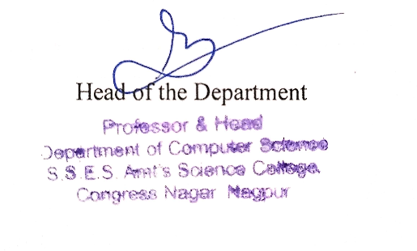

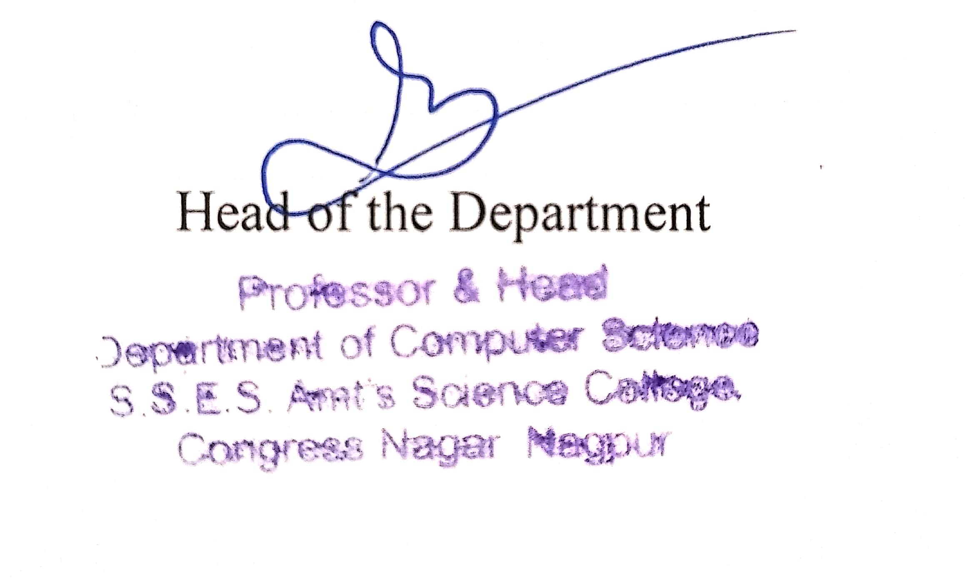 Head of the Department